Implement the class MovieTicket with the instance variables and methods mentioned below.

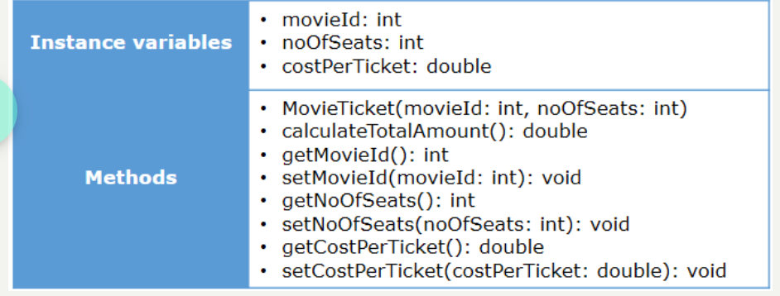

**Method Description**

**MovieTicket (int movieId, int noOfSeats)**

* Initialize the member variables movieId and noOfSeats appropriately with the values passed to the constructor.

**calculateTotalAmount()**

* Calculate the total amount to be paid based on the costPerTicket and noOfSeats by applying a 2% tax on the total amount.
* The costPerTicket for the movies are provided in the below table. Set the value of costPerTicket instance variable appropriately.

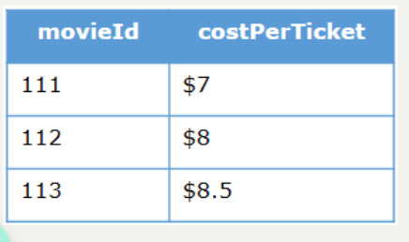

* Note: Return the total amount calculated after rounding off using the **Math.round(double a)** method.

Test the functionalities using the provided Tester class.

**Sample Input and Output**

**Input**

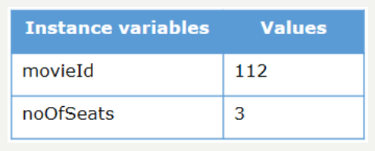

**Output**



**Input**

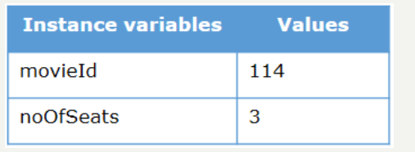

**Output**

